Campus Canteen Process Op0miza0on :

Tools Used : BPMN Swimlane Mapping, Process Optimization, Gap Analysis
1. The Problem
Students are facing extended wait times – up to 20 minutes between classes because the campus canteen has a inefficient workflow.
The Root Causes :
- One Giant Queue: Students queue up for everything (ordering, payment, and collection), creating a massive bottleneck.
- No Transparency: Nobody knows when their food will be ready, leading to students overcrowding around the collection counter, and contributing to the chaos.
- Reac4ve Cooking: The kitchen only starts preparing food after a receipt is printed, meaning they don't have a clue what’s coming their way until it's too late.
The Solu)on: Roll out a mobile pre-ordering app to slash waiting times to under two minutes and enhance kitchen productivity.

As-Is Process

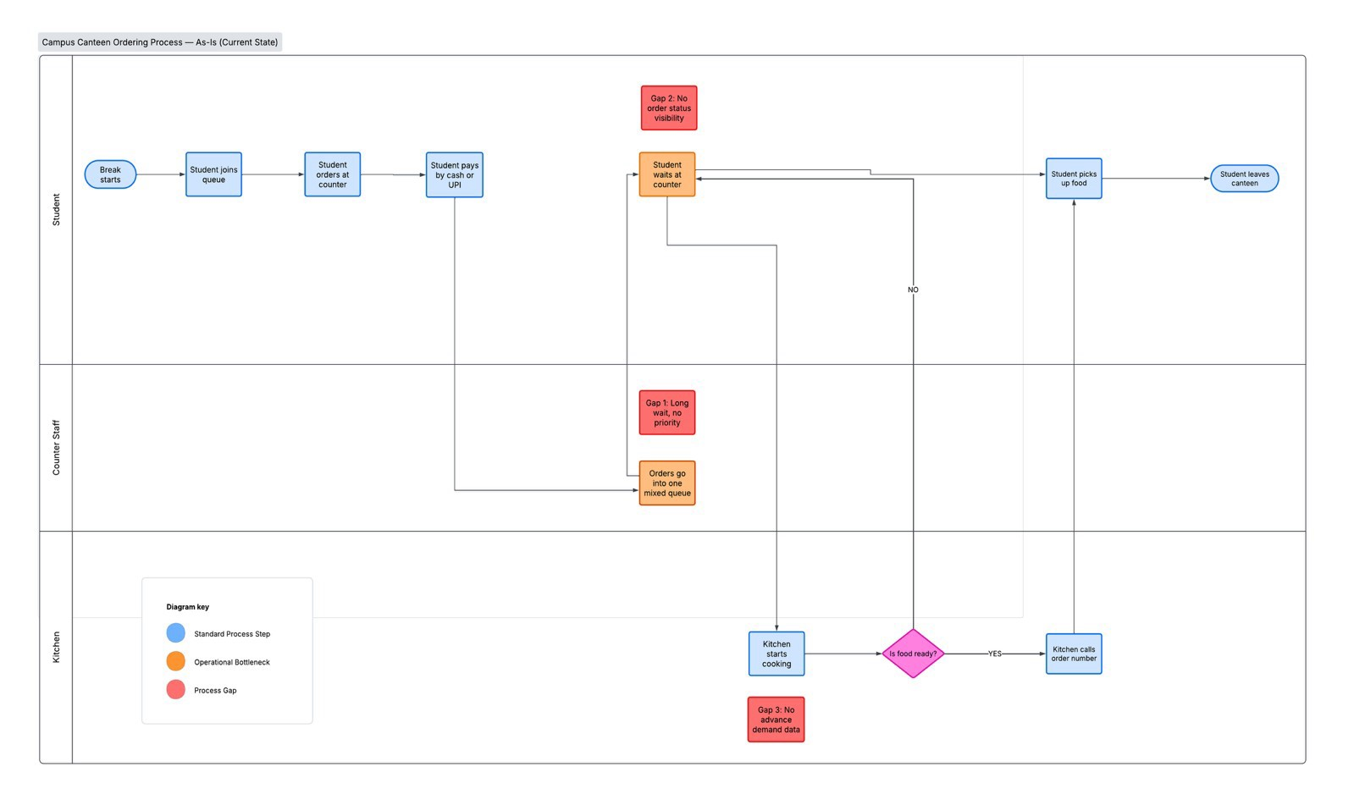
# The Core Issues
- Single point of failure for order, payment, and collection.
- Lack of process transparency and order tracking.
- Kitchen operates on a reactionary basis.

To-Be Process

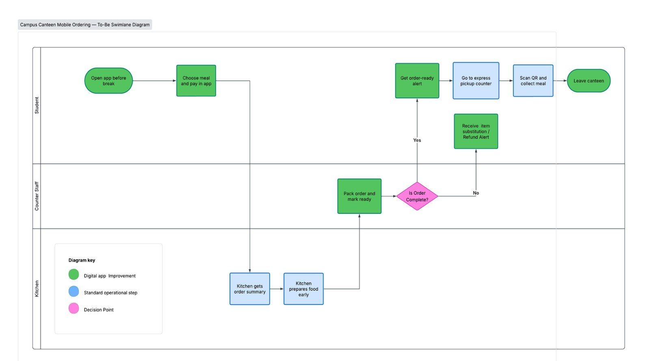
# How It Works
- Order and Pay in App: Students simply order and pay for their meal in the mobile app and select a time to pick it up.
- An4cipate the Kitchen: An order preview is sent to the kitchen at least one hour prior to busy periods so they know what to make in advance.
- No4fica4ons for Customers: An automated notification is sent to students’ phones once their meal is ready for pickup.
- Scan and Go: Students can head straight to the dedicated QR code scanner at the collection counter to collect their meal in seconds.
- Seamless Item Management: If any menu item isn't available, the app automatically refunds the cost or suggests a suitable alternative.

What We'll Achieve (Key Metrics)
- Reduced Wait Time: Decrease the average wait time from 18 minutes to less than 2 minutes.
- Increased Kitchen Produc4vity: Achieve 35% increased kitchen productivity through proactive ordering.
- Less Conges4on: Reduce the number of students overcrowding around the collection counter by 80%. 4. Enhanced Capacity: Double student throughput during peak times without any additional staff members.

